**EXPERIMENT 9**

**VIEWS**

**Aim:**

* Create table student with attributes id, name and department.
* Display
* Create view and select
* Insert values
* Create view with check option
* Insert values and alter table.

**Components:**

* A view is a subset of database that is generated from a query and stored as a permanent object.
* Instance: It is a collection of information stored in a database at a particular moment.
* Entity: Object that is relevant to the given system. It is represents as a rectangle.
* Attribute: Trait of an entity, relationship or other attribute. It is represented by oval.

**Schema:**

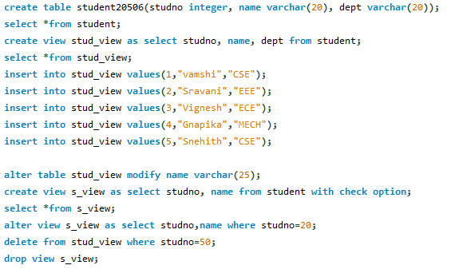

**Output:**

